Innovative Net Systems Presents:
The Great Carp Chase and Beyond
By Greg Faulkner

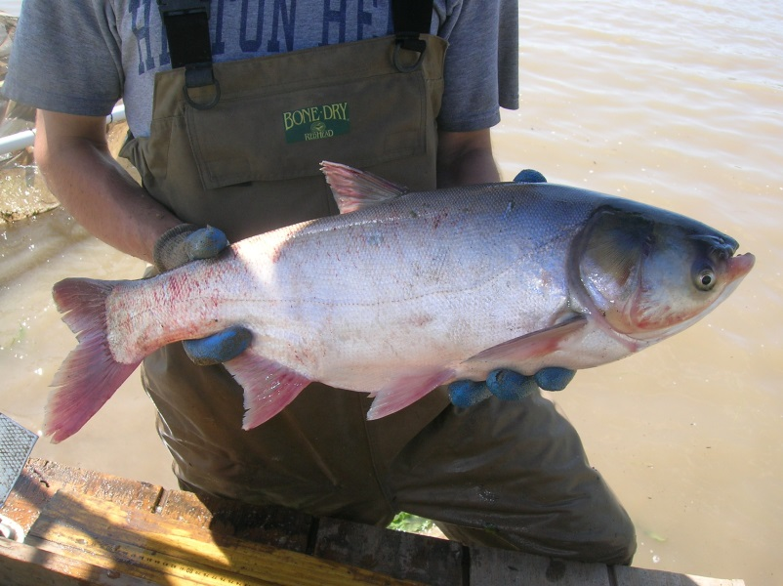

Having spent decades working with seines, pound nets and grading socks in the catfish industry, I was reasonably familiar with the grass eating carps. Little did I suspect that they would one day turn into a national threat to the environment.

The early beginnings of the team that would be called…… CARP RECON.
The USFWS contacted our shop, Innovative Net Systems in or around 2005 and open discussions about new type, outside-the-box gears that would catch large Asian carp. The scientists out of the USFWS office in Columbia, Missouri FRO were apparently spear heading this new endeavor. My contacts there were Tracy Hill and Wyatt Doyle.

After some long discussions, we arrived at our first plan. Innovative Net Systems would build a 200’ x 15’ deep Twin Trawl. This net would be deployed and towed by two boats, creating a huge swath down any water way chosen. These nets, in larger forms, are used worldwide. They had been proven to be extremely productive.

2005 found all of us standing on the banks of the Illinois River. The Great Carp Chase was on.

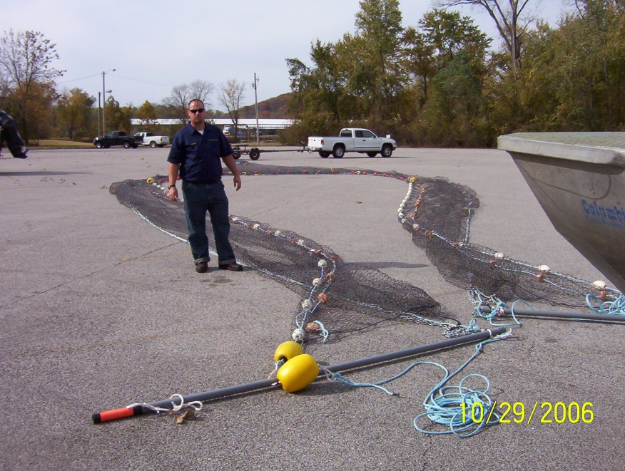
The Twin Trawl shown here laid out. Two 75’ wings and a 50’ wide funnel shaped holding section at dead center.

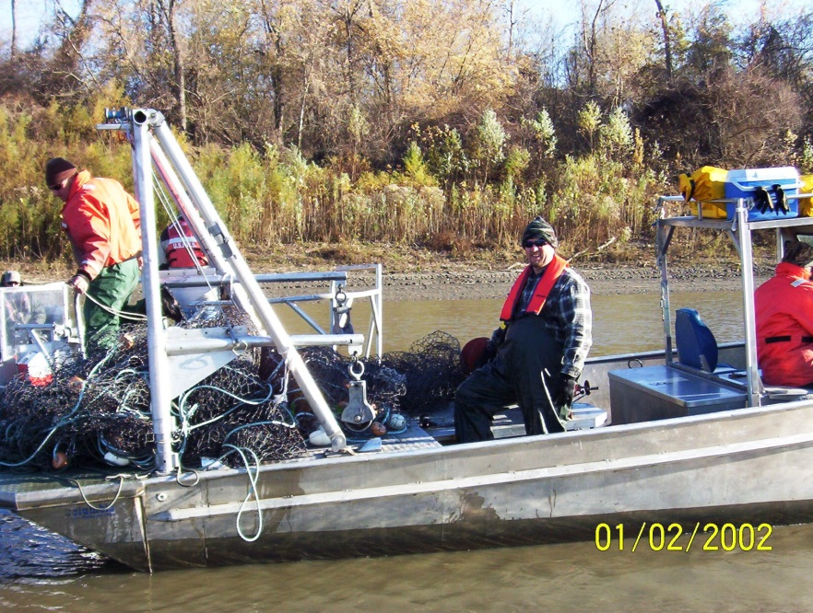
The net is deployed by one boat and then the second boat takes the Spreader Pole and the ‘trawling’ begins.

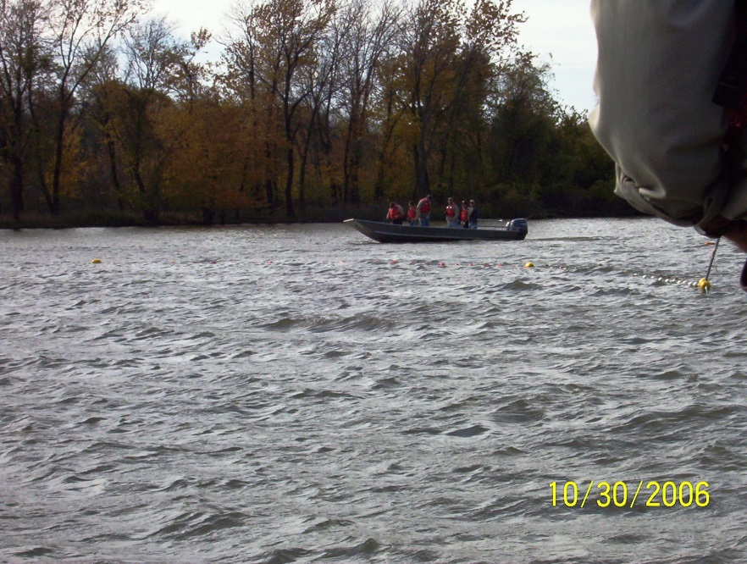
Two boats… One net… Illinois River, 2006.

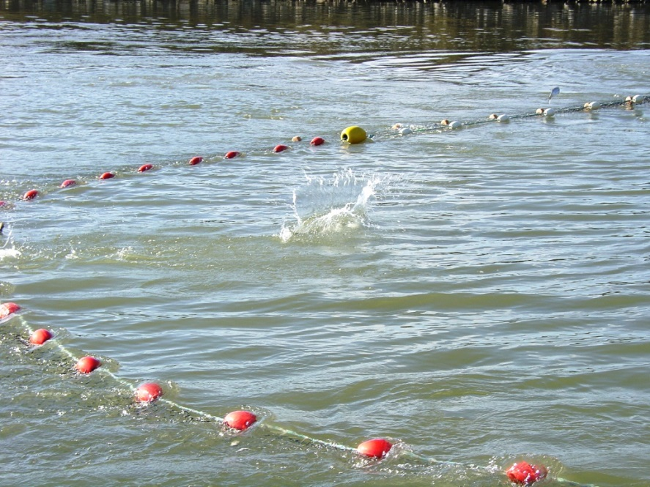
The net had no trouble interacting with Asian Carp. They could be seen readily hitting the cork line. However. . . . . . When we hauled in the seine pocket we had hardly any catch of Asian Carp. Repeated tries showed that the carp were swimming in, turning around and swimming back out. In some instances they simply hit the net and then dove under it. In other case the fast moving torpedoes just ran ahead, way ahead, then disappeared into the river system.
We had brought a knife to a gunfight.
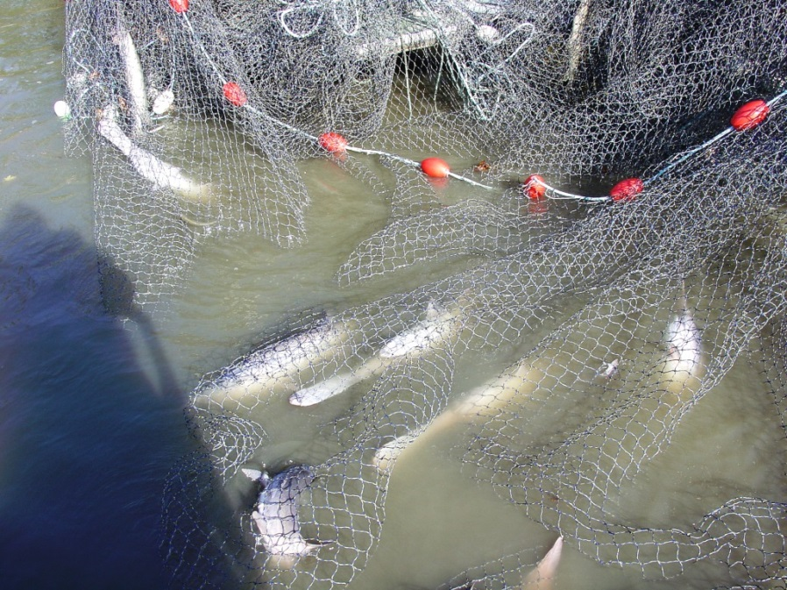
…… so we went to Plan B and rigged a Purse Line to the Foot rope of the Twin Trawl, now turning it into a modified Lampara –Ring Seine. MDC assisted with deploying the ‘new’ gear and we caught a batch of fish . . . only the catch consisted mostly of Paddlefish, with just a few carp. Some of the scientists present were excited as they were always looking for new ways to take live caught Paddlers. We were still looking for a chink in the armor so to speak, of these elusive Asian carp.

We learned a lot by this first trip. We learned what NOT to do. Knowing which direction NOT to venture in is a huge part of any net design R&D endeavor. We were a lot smarter in this area now..

The plankton eating fish were showing up everywhere. Shrimp trawlers in Vermilion Bay, Louisiana, just 2-3 miles from the Gulf of Mexico were catching 20 pounders in their trawl nets!
Up North, gill netters were quite capable of taking the fish in large numbers and for a while it seemed there would be a huge press by commercial netters to take and sell the fish, thus eradicating them by sheer fishing pressure.

Innovative Net Systems continued on with its work in research gear. Projects like the USACOE Pallid Sturgeon kept us busy. NOAA and NMFS kept us occupied with sampling gear as did numerous universities. Many private companies working everywhere from the Beaufort Sea to the Solomon Islands, offered us a chance to design deep water gear…all outside-the-box creations, our forte’. Still, we kept in touch with our customers in Columbia and held impromptu discussions on a monthly basis, concerning the Asian carp situation.

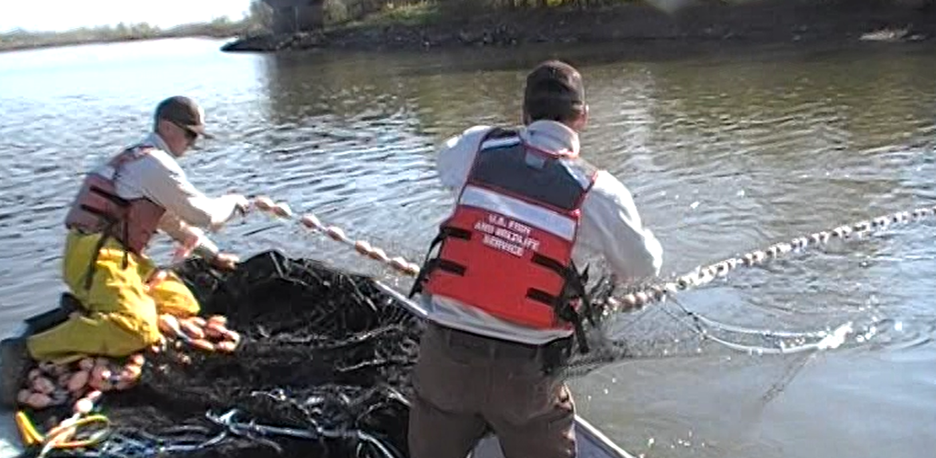
2010 found Innovative Net Systems teaming up with its old partners at the USFWS Columbia FRO once again. It seemed fish sales alone were NOT knocking back the numbers. A new problem was developing in that many northern states wanted to know exactly where they stood with Asian Carp populations. They wanted to know if, when and where these fish were spawning. Commercial netters could only give them catch rates at the locations they worked at.
This time around we laid a different plan. Long discussions with Wyatt Doyle and Tracy Hill at the Columbia station, determined that it may be better to encircle the fish rather than force them into a net. The Purse Seine was brought up.
So, in 2010 Innovative Net Systems constructed a small 600’ purse seine complete with all the trimmings such as ring line, bunt and tapered wing segments.

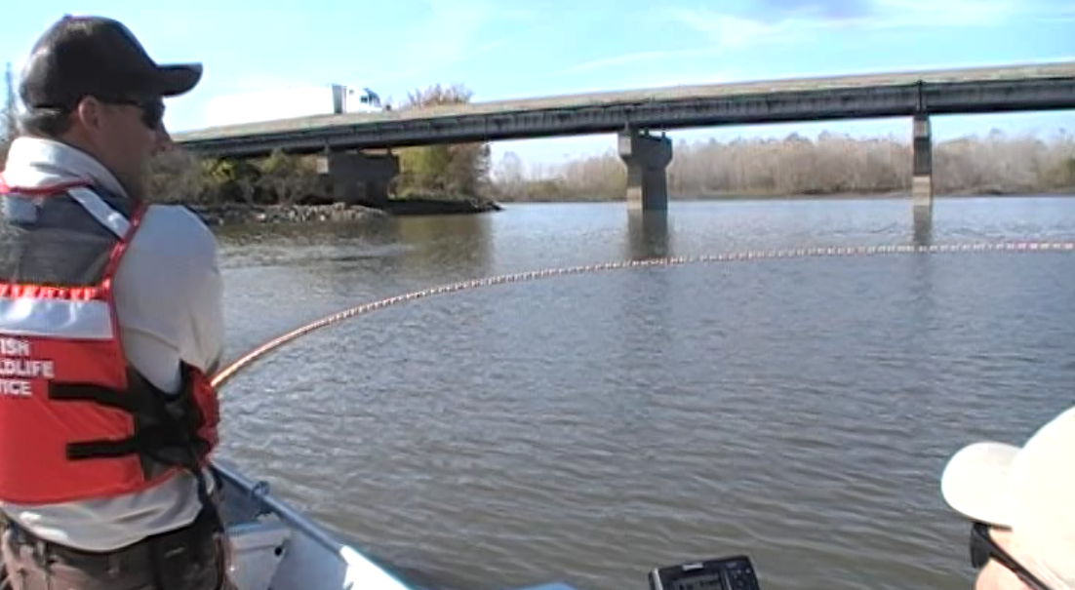
Soon after the first run of the new seine, we had yet another problem. The horrific amount of debris and the shallowness of the areas to be worked, produced endless snag after snag…holding the net open just long enough for the fish to escape. It was just too shallow for the seine, which at 15 feet deep, was already at the absolute lowest limits of a functional Purse Seine. Even if it did show promise, the Purse Seine was difficult to work out of the small, research boats that the USFWS had. We needed a real purse seine skiff, 30’ or so, complete with hydraulics, to work a true Purse Seine. Another lesson learned: Even if the gear shows promise, you have to have a viable delivery system.

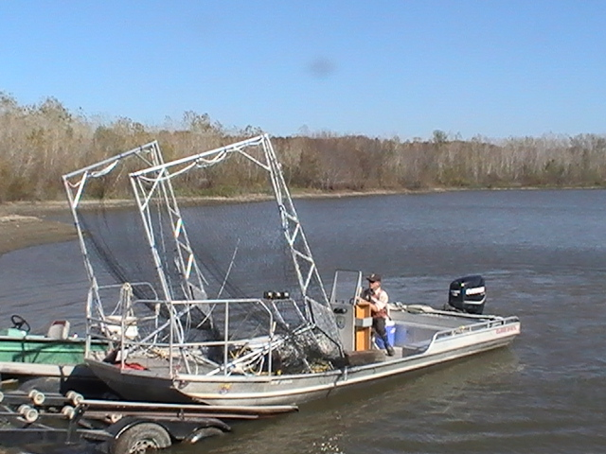
It had been discussed months earlier, that a surface fishing gear that could be extremely fast and mobile, might show some promise. I introduced the USFWS to the Paupier (Butterfly) net system.
Within a week, USFWS had their frame work in place. Of course there were some on-site modifications made to fit their hull. The Columbia crew became quite adept at modifications. Finally, the first Paupiers ever used on Missouri waters were mounted on a large Clark Skiff and the next phase of the Great Carp Chase was on again.
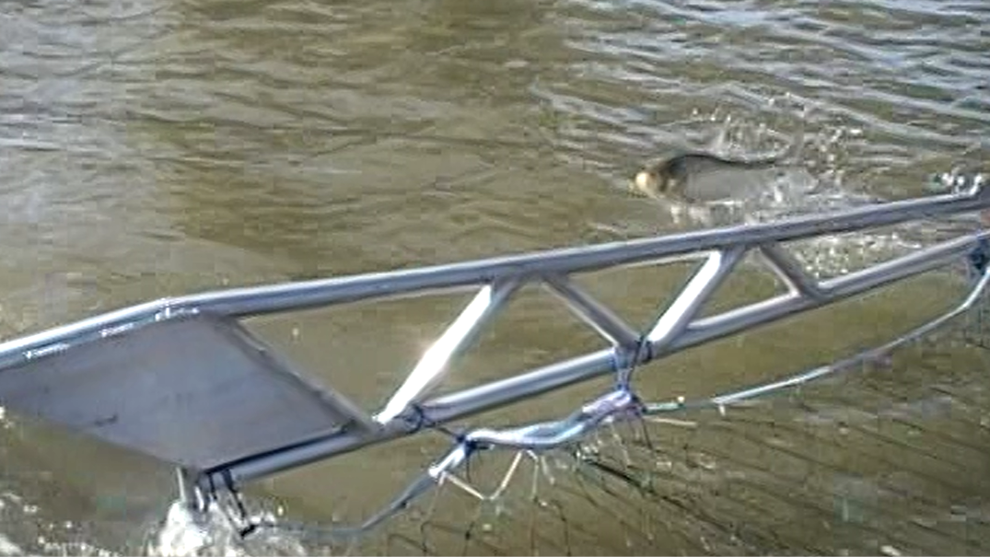
The first field trails did not catch as much as we wanted, but now we could see HOW to catch the big carp. Stay on the surface, make better speed, and run them down.

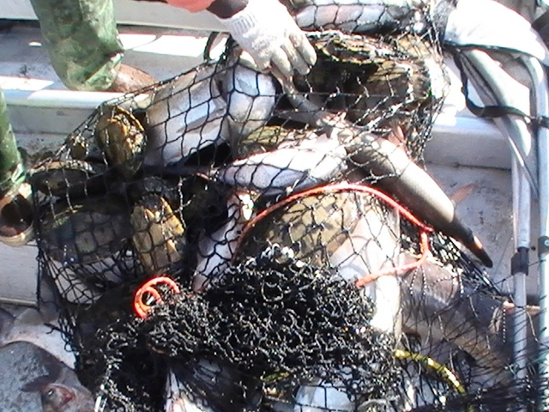
Besides carp, we were picking up lots of other species.Some scientists studying everything from garfish to paddlers were now keen on the Paupiers. Seemed one thing led into another and by accident, we had created a sampling method for these other species.
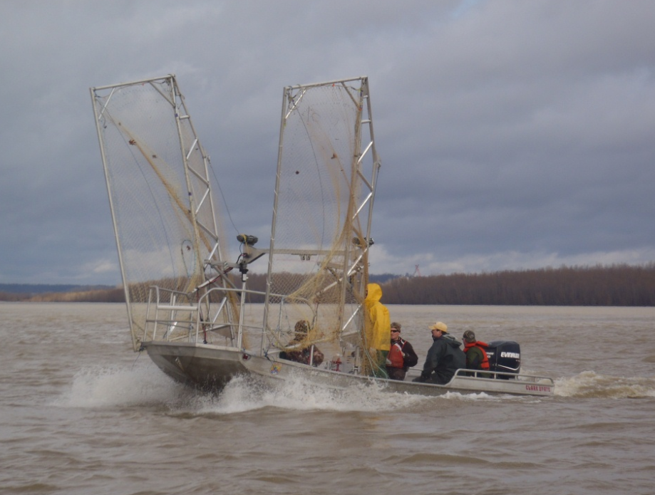
Taking input from the USFWS’s almost weekly field trials, Innovative Net Systems cranked out a new design or modified design almost every two or three weeks. High end nettings like Ultra High Density Polyethylene (Dyneema) were brought in from overseas and implemented in what was now the fastest Paupiers Innovative Net Systems had ever built... Period!
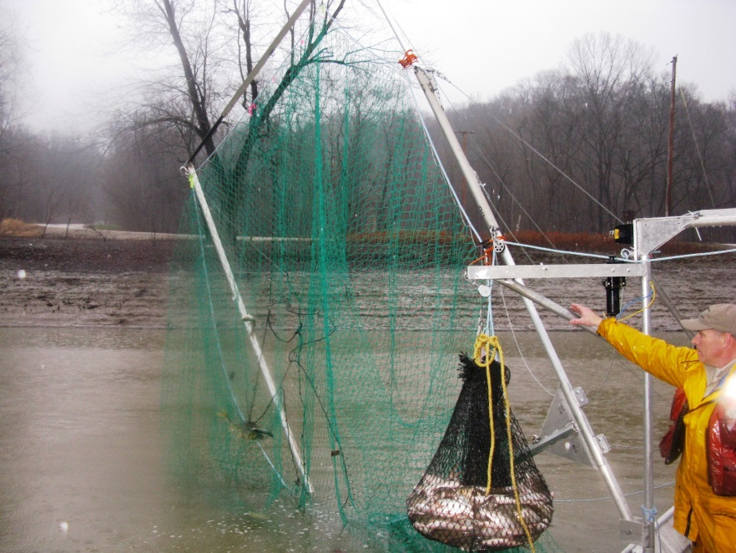
A big break in this R&D was looming. Every one of us could sense it.

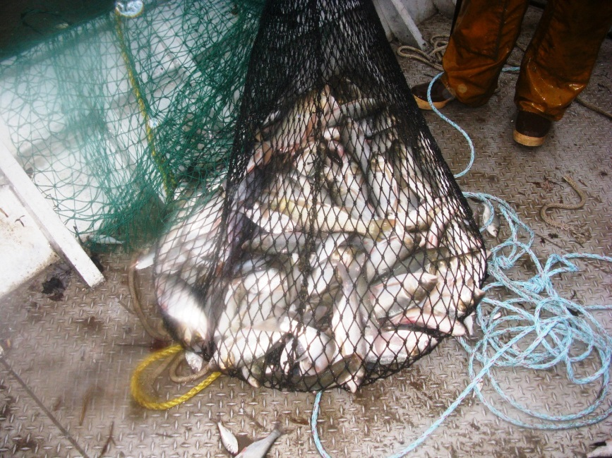
Different net configurations were developed. Vortex Funneling, Baffles, Suspension hoops, Slot Escapes…. Innovative Net Systems and the Columbia scientists (now dubbed CARP RECON) were way outside-the-box of traditional gear.

Critics mounted some opposition. Comments about Paupier nets and Purse seines being outside the norm and classified as “playthings” were surfacing at meetings. Still the Columbia scientists stood fast. They knew they were in the final trials of sampling tools that would break the old adage that ‘Asian Carp’ were too elusive to monitor properly.

It was around this time in the R&D work that the emphasis suddenly changed. No longer was there just a concern for a harvesting tool, but rather state and federal authorities now wanted more reliable ways to determine the extent of the carp invasion. They wanted Intel on Proliferation and Spawning locations.

- Where were they?
- Where did they spawn this year?
- Where are the Y.o.Y. ?
- Did they breach the Barrier?
- Were they in the Great Lakes yet?

Carp Recon was on it! It would take a few months of field trials but we all had confidence that locating fish 1” through 30” was NOT going to be that difficult, in spite of what the critics claimed.
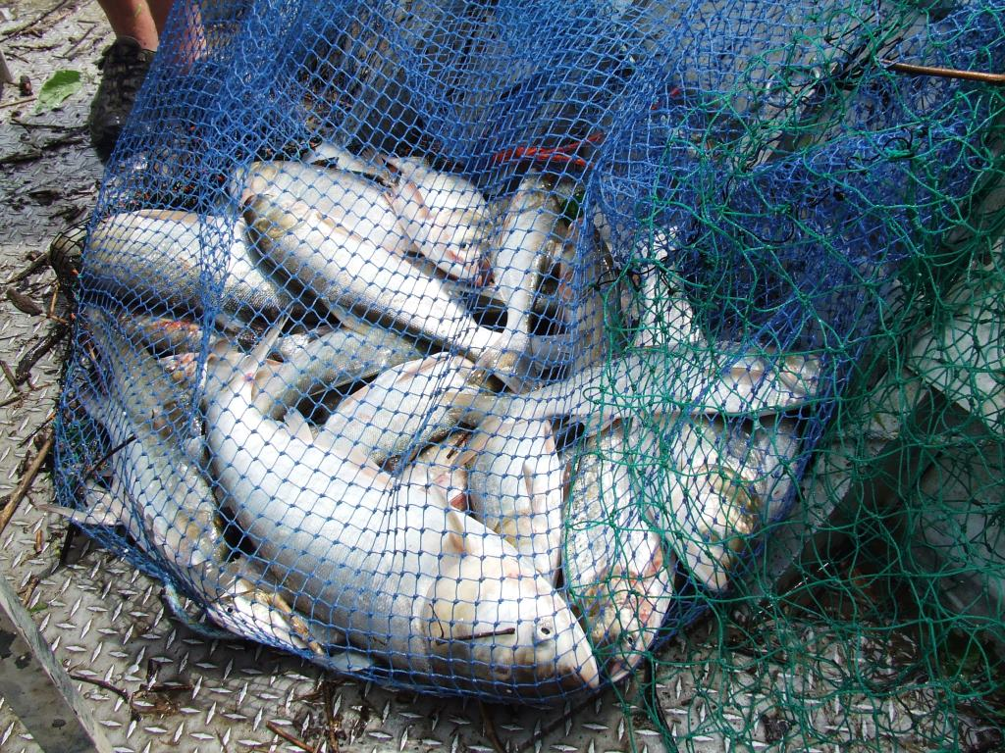

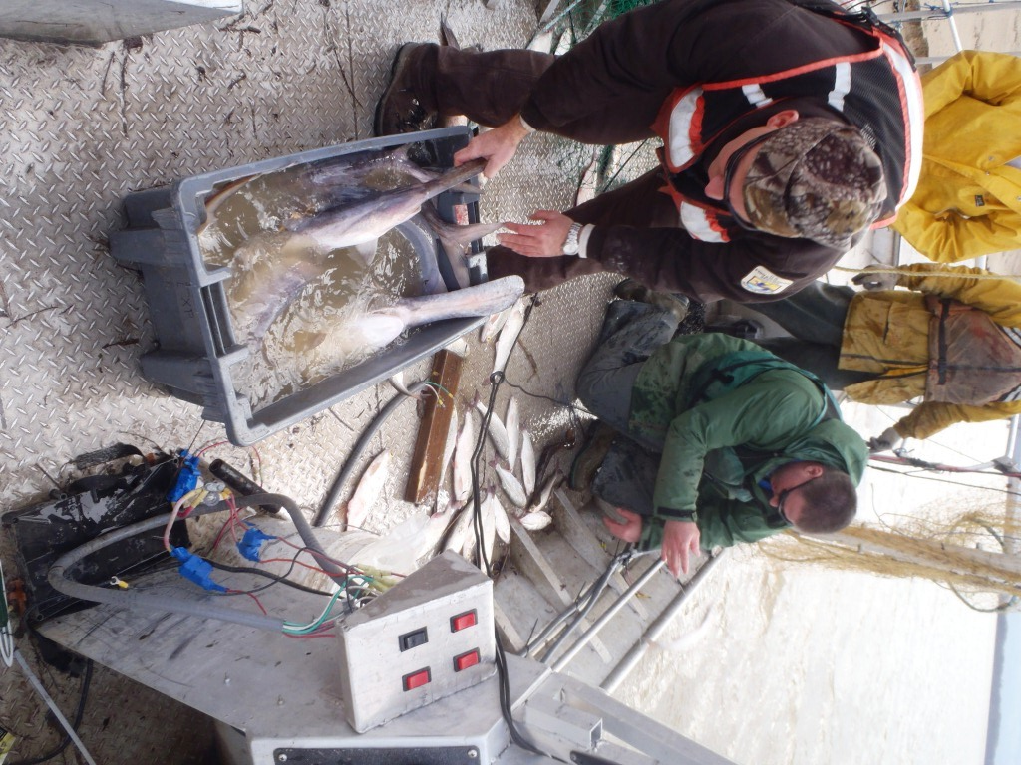
* SIDE NOTE*
One fact held steady through all of this. The Paupiers were producing an ever present catch of Paddle fish. In fact, Wyatt’s crew and gear were now able to locate and take juvenile paddlers that in the past had been almost impossible to find. It was lagniappe!

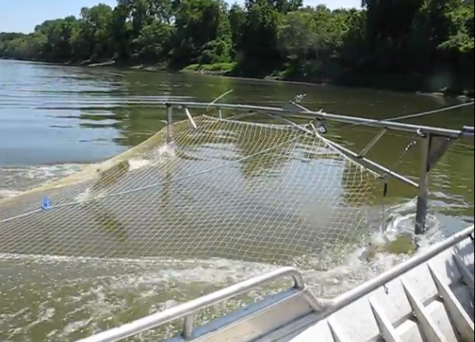
Thinking ahead, Wyatt decided to bring in some very sophisticated sonar to take an underwater look. It was then, that we saw something that led us to make one more serious advance...Electricity!
Innovative Net Systems had worked with USL on an electric crawfish harvester. We also built the basic net system for the Penn State Electric trawl. So, why not Electric Paupiers? The Columbia Crew already had vast experience with fish shocking, making this an easy call.
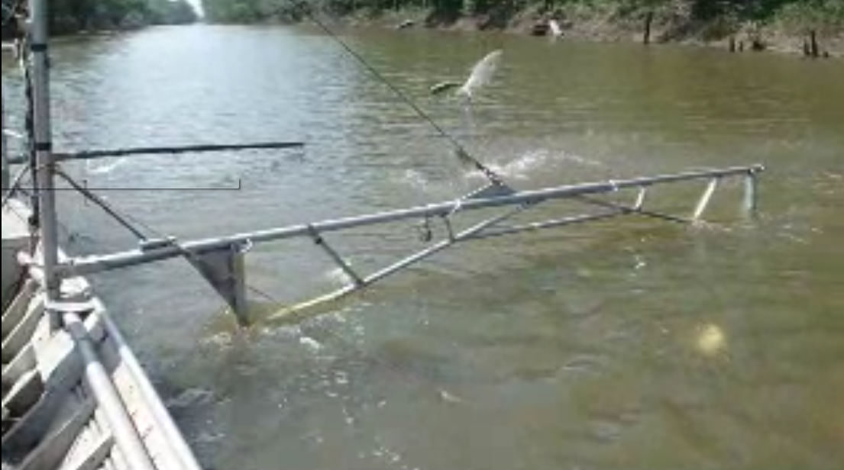
With the help of USFWS fish shocking expert Jan Dean, a very unique shocking unit called “The Genie-in-a-Box” ….. The Electric Paupier was born.
* Jeff Finley, USFWS Carp Recon Team, was instrumental in fabricating the unique trussed Paupier frames*

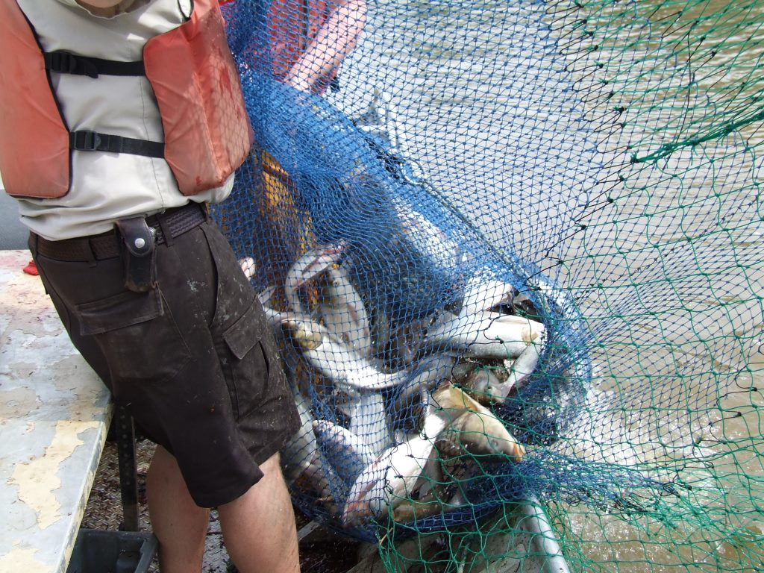
. . . .And the catch rates from the 10 minute runs began to rise steadily.

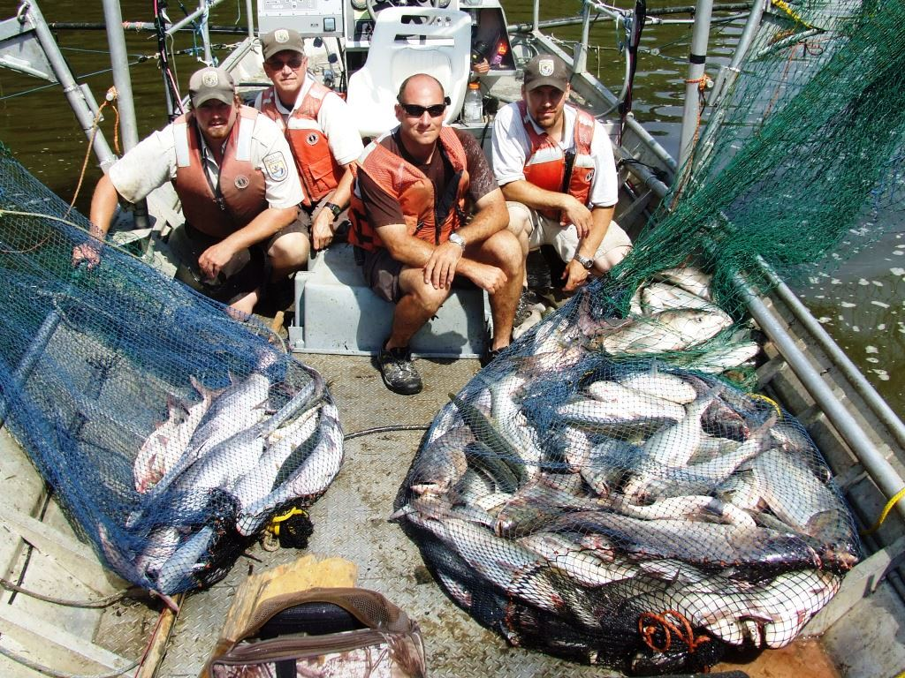
…and continued to increase . . .
We added Fish separators, ATF accelerators, Vortex funnels, Accordion Lines, and Kodiak Bags to the arsenal. No, you won’t find any of these in a fishing catalog on the internet or the American Fisheries Society’s "Standard Methods for Sampling North American Freshwater Fishes". They haven’t caught up with us yet.

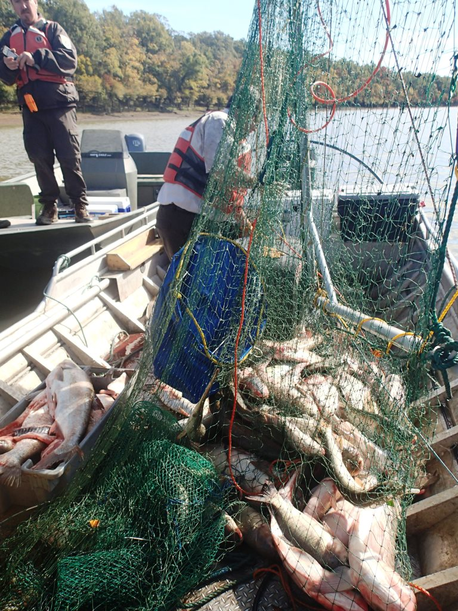
Finally, catch rates grew so large that winches were needed to haul in the loads of Asian carp. * Shown here is a 10 minute catch* 400-500 lbs. per 10-15 minute sets were now possible.
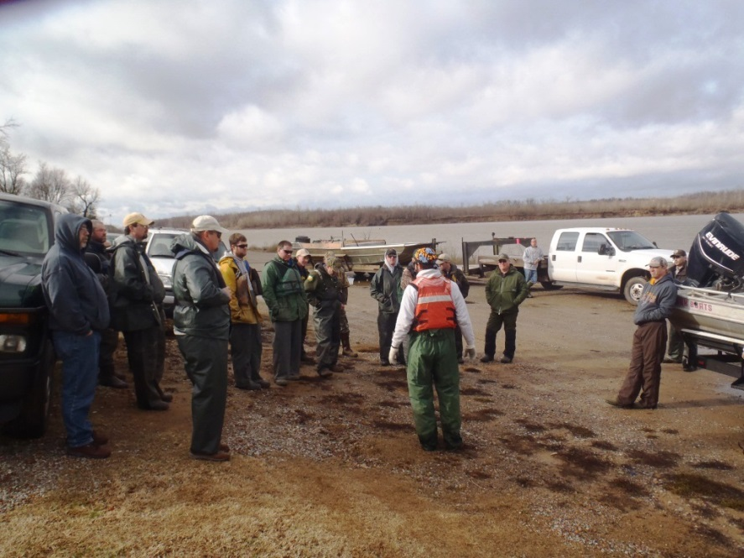
Interest in the new methods was growing. The Paupiers were no longer called playthings. The gear worked and the Columbia USFWS FRO Carp Recon was farther ahead on sampling methods than any other agency in the Midwest. Scientists from around the region requested information from the Columbia crew.
Some folks chided in that their budgets didn’t allow for the expense of a Paupier Shock Boat and nets. Was there an alternative? After all, they just wanted to sample, shallow, backwaters for the presence of Y.o.Y. carp.
The Columbia crew taxed Innovative Net Systems once more. The requirements were simple; 18 foot hulls, NO shock apparatus, small hp outboards, no winches and still able to sample Y.o.Y. fishes in very limited, shallow backwaters.

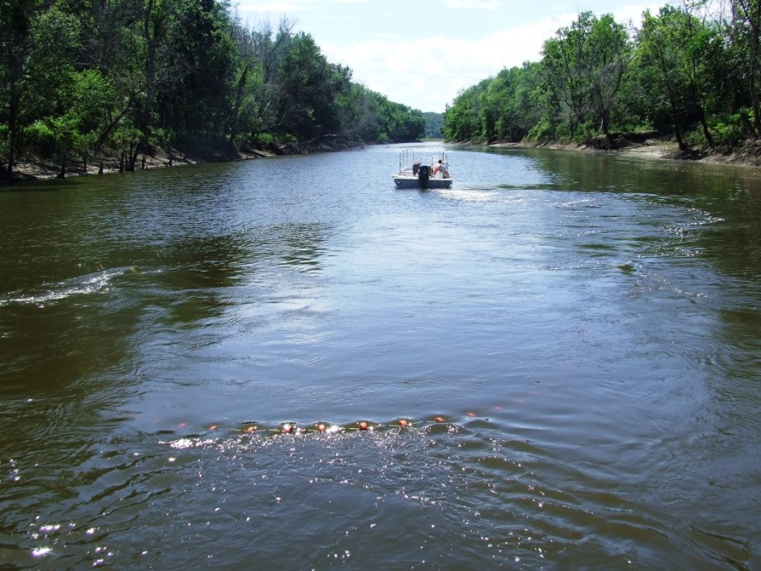
Innovative Net Systems responded with a gear called the Mamou Trawl. It is a Surface fishing gear that takes most anything between the surface and 3>12’ down…. Your choice of widths and depths. No, it was not 100% effective on all sizes of fish, but it did effectively take the Y.o.Y. carp in 1”>4” sizes, with some larger fish occasionally.
It works by hand from almost any 18’-20’ hull with at least 100 hp….and it can go deep into the back waters where the Asian Carp spawn. The Mamou has proven ideal for this kind of surveillance.
* Y.o.Y. Asian carp do not necessarily jump out of the water as much as the adults do. Just riding around in a boat looking for “jumpers” will NOT work. Seining and fyke nets (the customary and traditional method of sampling) required days and days of setting and monitoring, as well as several boats and crew. In just a few hours of sampling, the Columbia crew (with one boat) could tell if there were newly spawned Asian carp in an area or not.

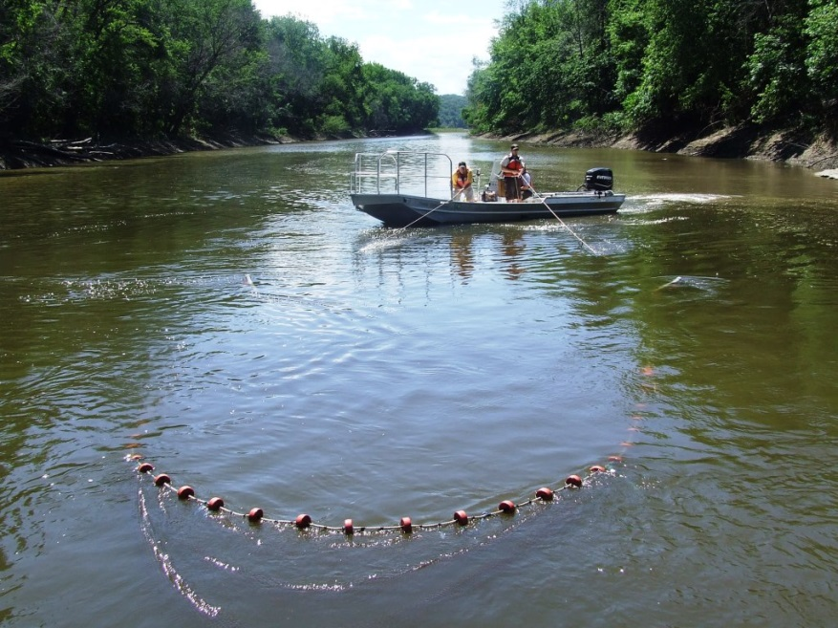
Mamou being hauled back in. USFWS, Missouri back waters.

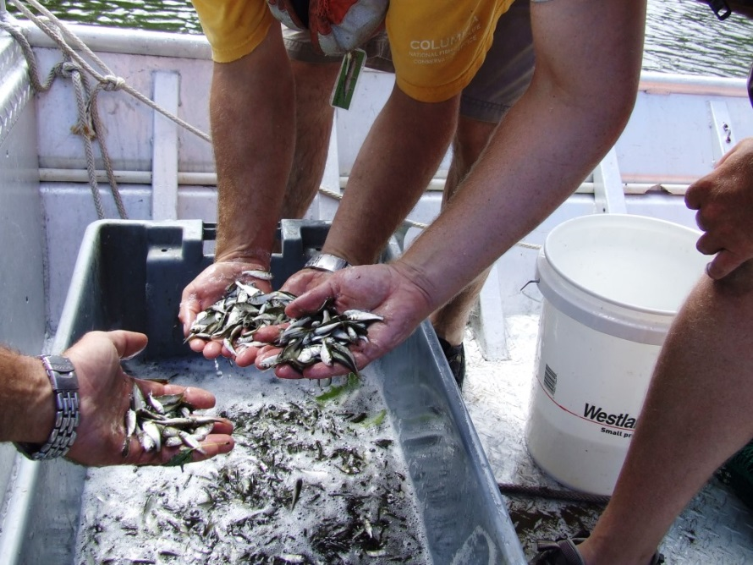
Y.o.Y. carps.

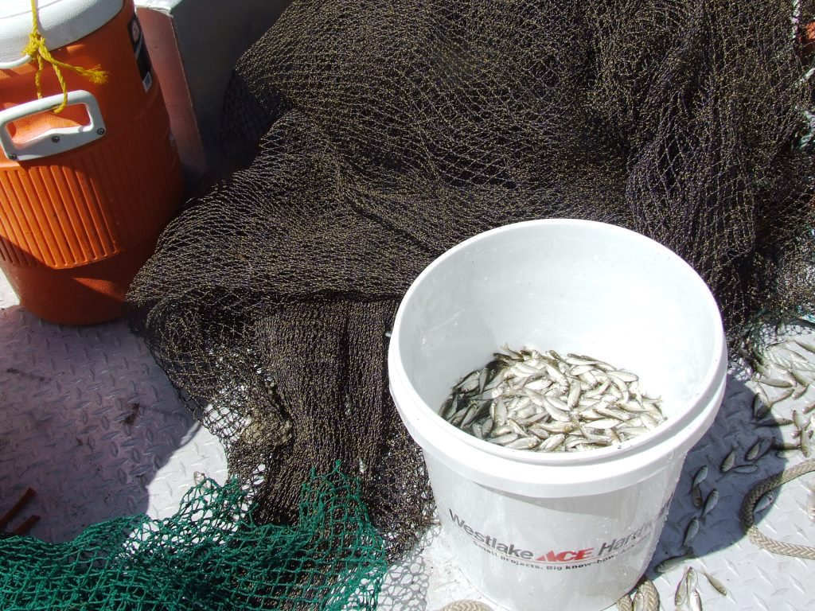
10,000, Asian Carp Y.o.Y. . . . . . . In just 10 minutes.
There was hardly a place these fish could hide that Carp Recon could not find them.

This has been the story of a partnership between Innovative Net Systems and the USFWS. It was a long and sometimes painful story especially when gear did not work out or there were other physical setbacks. But all in all, there is now on the water, a pair of gears that can monitor the whereabouts of Asian Carp from Y.o.Y. through adult stages.

Innovative Net Systems has been tasked to improve the Mamou trawl with hydro-dynamic trawl doors for faster and wider deployment in TIGHTLY controlled places (Like the Chicago Canal). The old purse seine is getting a makeover that will turn it into a Danish Seine and hopefully be more user friendly in heavy detritus areas. The Paupiers are being revamped to hold even more carp and to sample very small Y.o.Y. fingerlings. Carp Recon will play a huge part in this next evolution of gear.

PLEASE READ. . . . IT’S VERY IMPORTANT
Plagiarism, Design Theft and Knock –Offs
After 8 years of developing target specific gears for Asian Carp, Innovative Net Systems has a growing fear that other companies that did not possess our skills at design, will now jump on the band wagon and attempt to copy some of our finished gears and possibly turn them into inferior knock-off nets.
As a small, family business…. One of the very few left in the USA…. We ask that our customers and their supervisors STOP for a moment and consider;
“You make your living with this gear. Why take a chance on someone whose only net making skill is to copy an already designed gear. If the other guys call themselves net makers, then let them MAKE THEIR own nets…NOT COPY OURS!”
Help us by staying with the shop that has been involved with this program for so many years. Knock-Offs hurt everybody! PLAY FAIR!

Log in to our website to view video on the new Electric Paupier net system in use by the Carp Recon team.

Innovative Net Systems * PO Box 255 * 111 Zothique rd. Milton, Louisiana * 70558 * 337-856-1948
Net-maker@cox.net see our Website for more details on our company www.fishtrawls.com

